1)Implemented the below options in settings
1) selenium with python
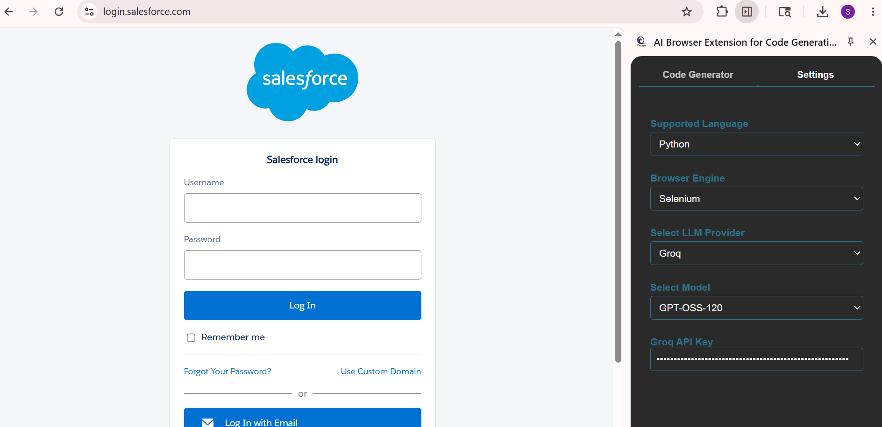
2)playwright with typescript
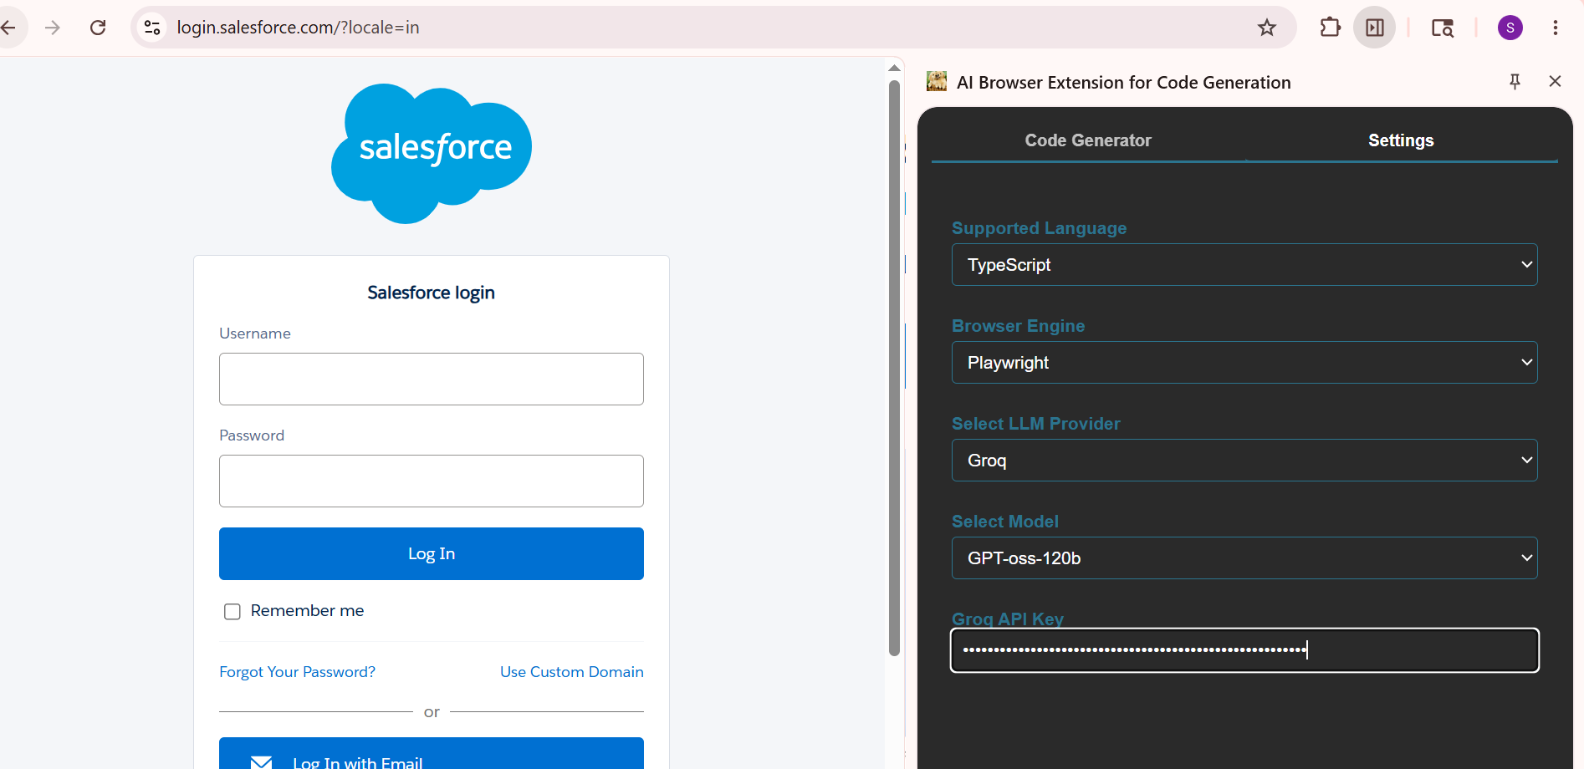
Click on the inspect and inspect an element in the UI and generate the page class
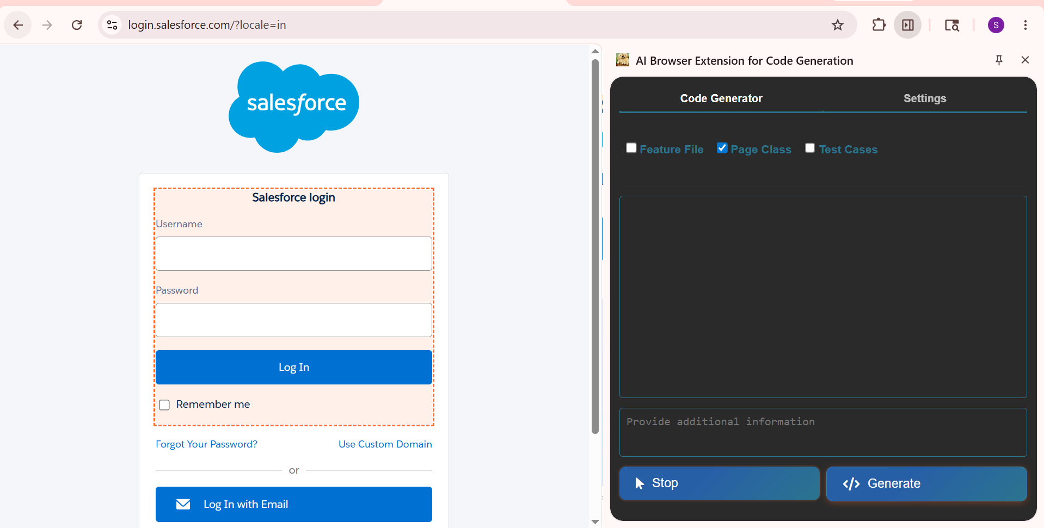

Output :
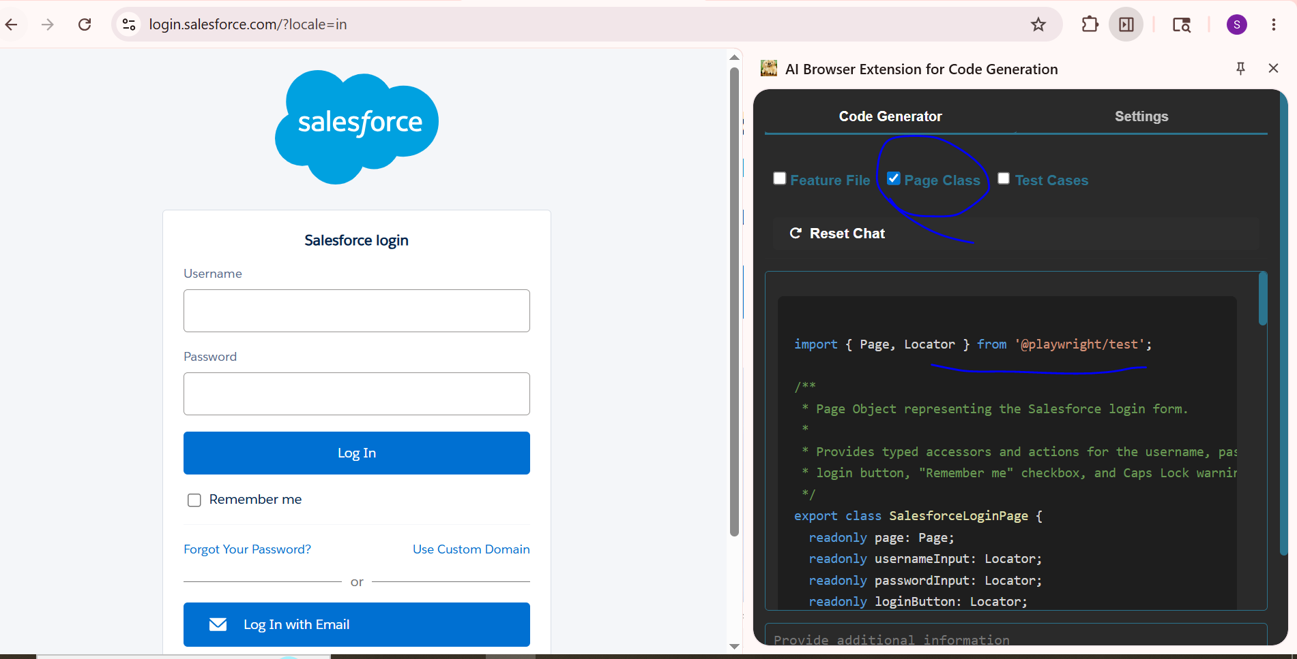
2) Implemented the test case generator
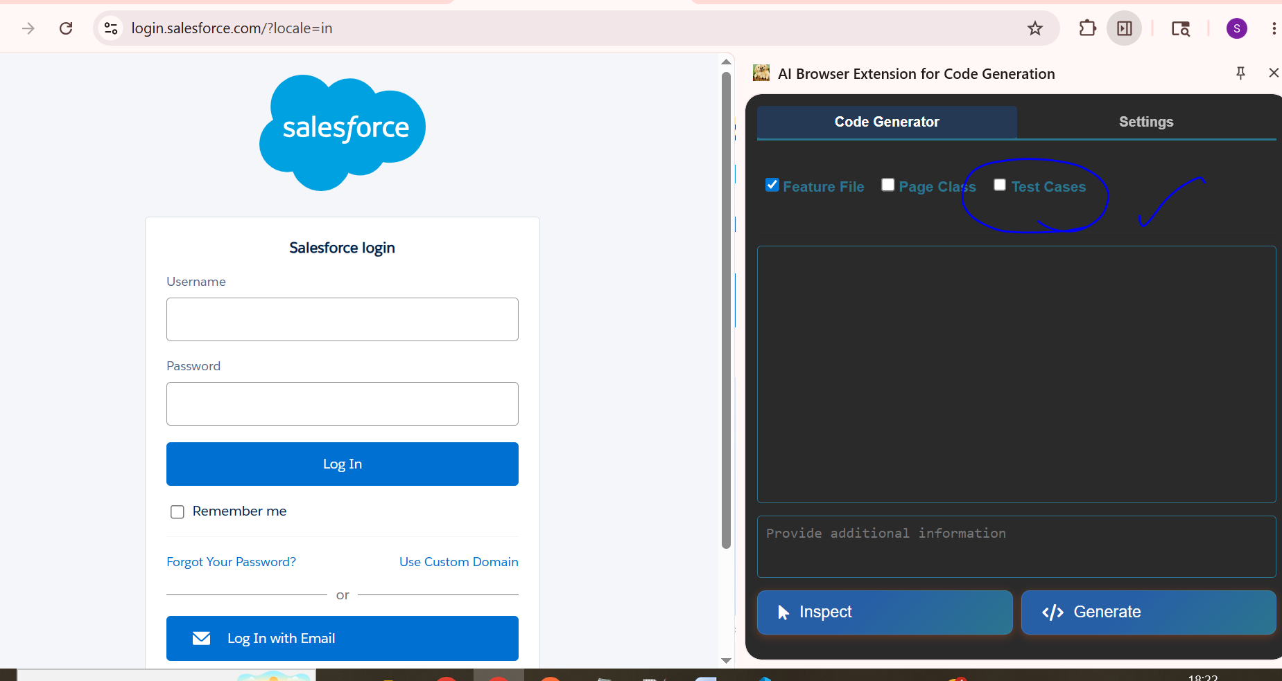
Prompt used-
You are enhancing an existing Chrome Extension Code Generator application.

Requirements:

[MUST]
Add a new option named "Test Cases" in the "Code Generator" tab, positioned beside the existing Page Class option.

[MUST]
When the user selects the "Test Cases" option, the application must generate Functional Test Cases dynamically based on:
1. Selected Programming Language
2. Selected Browser Engine

[MUST]
The generated test cases should align with the output/code generated for the selected framework and browser configuration.

[STRICT]
Do NOT modify or break the existing functionality of:
- Inspect button
- Generate button
- Existing Page Class generation flow

[MANDATORY]
The generated test cases output must be displayed in tabular format with the following columns:
1. Scenario
2. Steps
3. Expected Result
4. Actual Result

[MANDATORY]
Generate exactly 5 test cases only.

[MANDATORY]
Include only Priority P1 and P2 functional test cases.

[STRICT]
Do NOT generate duplicate test cases.

[STRICT]
Generate only functional test cases relevant to the generated automation flow.

Expected Outcome:
A new "Test Cases" feature is added without impacting existing extension behavior, and users can generate structured functional test cases based on selected language and browser engine.
click on the test case option and check if test cases are generated
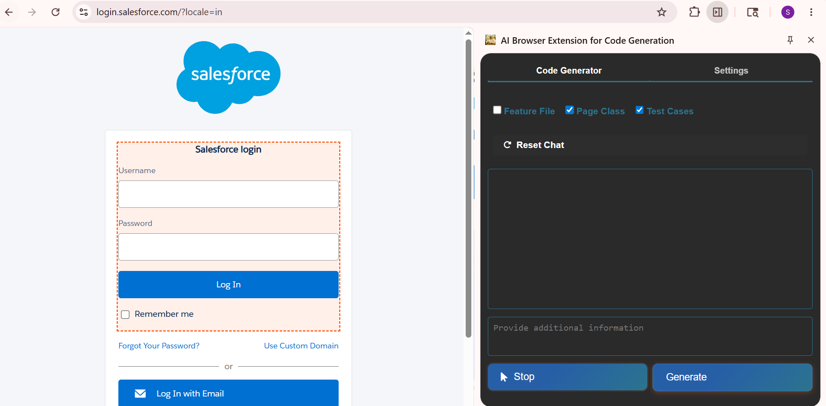

Code –
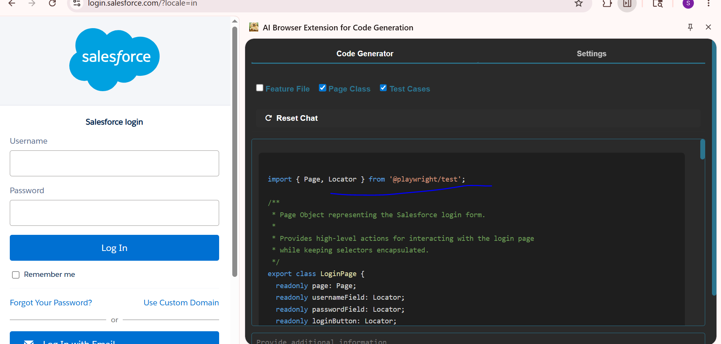

Test cases-
